**IoT Based Smart water Management**

**A Project report submitted in partial** **fulfilment of the requirements for the**

# degree of B.Tech-Informatoin and

**Technology**

**BY**

R. PRAVEENA

513221205012

**Under the supervision of**

**Professor & HOD**

**Department of B. Tech- Informatoin**

**Technology**

Smart Water Management

**PHASE-1 PROBLEM DEFINITION AND DESIGN THINKING**

# Problem statement Design Thinking approoach

**Problem statement:**

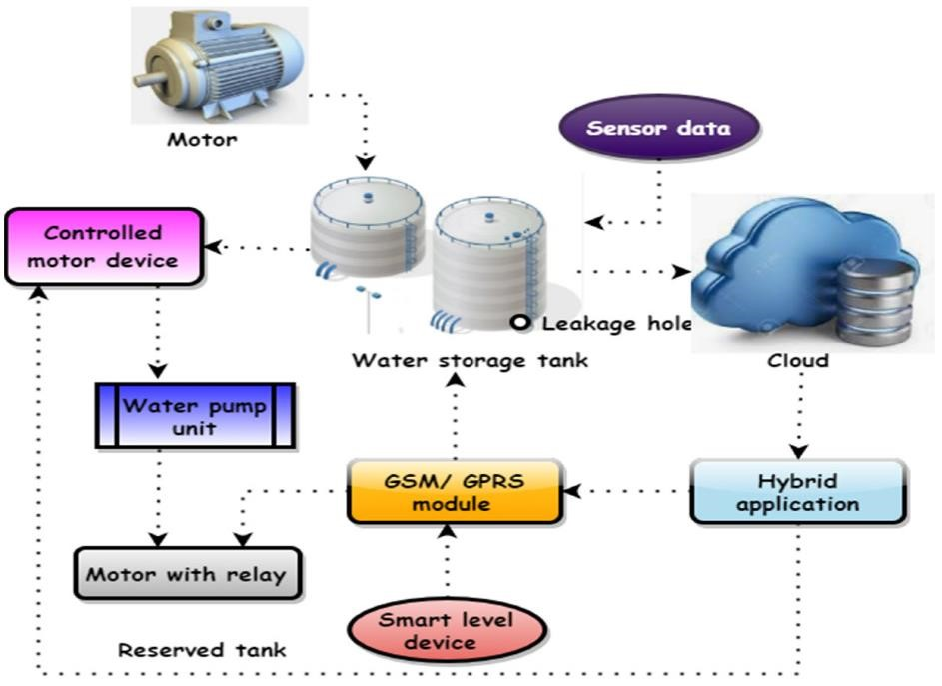

In the 21st century, there were lots of inventions but at the same time were pollutions.

Global warming and so, on are being formed, because of this there is no safe drinking water for the world’s pollution. Nowadays, water quality monitoring in real time faces challenges because of global warming limited water resources, growing population, etc. Hence there is need of developing better methodologies to monitor the water quality parameters in real time. The monitoring of water quality is extremely important for maintaining the safety of water resources used for various purposes.

IoT is progressing with millions of things connecting each day to generate large amount of information .

(Internet of Things) based water quality monitoring has been proposed. In this project, we will implement the design of IOT for monitoring system that monitors the quality of water in real time.

*A. Micro Controller-* TheAtmega328isa one of thevery popular microcontroller chip produced by Atmel It is

an 8 -bit microcontroller that has32Kof flash memory,1K Of EEPROM,and2K ofSRAM.The Atmega328 is one of the microcontroller chips that are used with the popular Arduino boards.This microcontroller hasanalogpin and digital pin for easy interface of the =MicrocontrollerOperating Voltage: – 1.8 - 5.5V23

Programmable I/OLinesTwo 8-bit Timer/CountersReal Time Counter with Separate OscillatorSix PWM Channels6- channel 10-bit ADC .

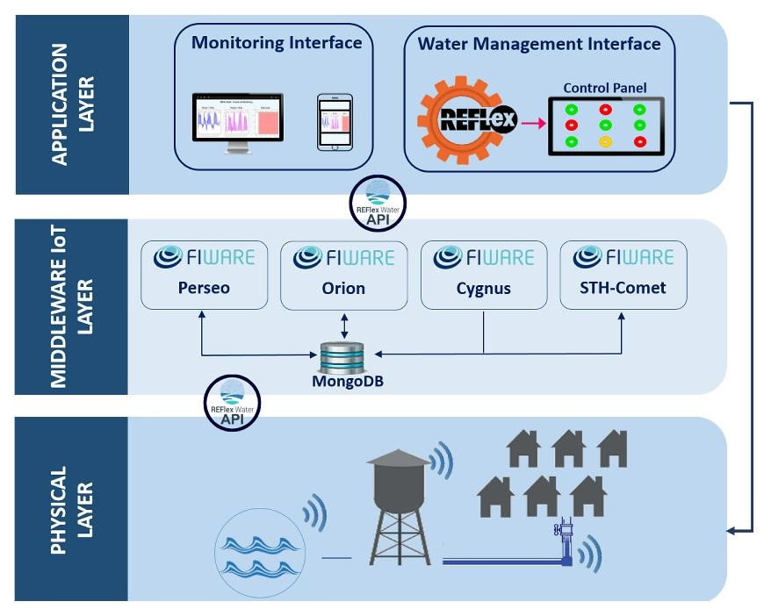

*B.IOT Module*

Wi-Fi Direct (P2P), soft-APIntegrated TCP/IP protocol stack+19.5dBm output power in802.11b modeSupports antennadiversityPower down leakage current of <10Ua Integrated low power 32-bit CPU could be used as application processorSDIO 2.0, SPI, UARTWake up and transmit packets in <

2msStandby power consumption Operating Voltage :

Is exceed and it is burn the esp module. GND is connected to the ground terminal. Rx pin is the receiver pin UART serial communication The Tx pin is a transmitter. GPIO general purpose input and output .Reset pin reset the module apply in 3.3v. the CH-PD pin configure channel.

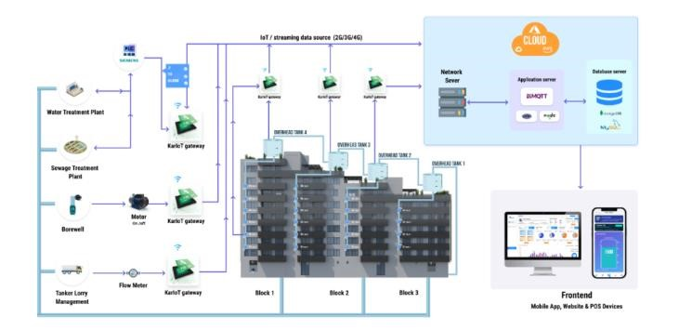

# Design Thinking approach

**MISO** pins on both the master and slave are ties together. Even though the Signal in MISO is produced by the Slave, the line is controlled by the Master . The Master generates a clock signal at SCLK and is supplied to the clock input ofthe slave. Chip Select (CS) or Slave Select (SS) is used to select a particular slave by the master.

Master – Out / Slave – In or MOSI, as the name suggests, is the data generated by the Master and received by the Slave. Hence, MOSI pins on both the masterand slave are connected together. Master – In / Slave – Out or MISO is the data generated by Slave and must be transmitted to Master.

Configuration of nRF24L01

RF24 radio (CE, CS) --- mention the pin connection

Mention the pipe address

Uint64_t pipe = 0xE8E8F0F0E1LL

Radio.begin (); Start the process

Radio.openWritingPipe (pipe)

Radio.write(msg,1); Radio.startlistening();

Radio.available() – to check any incoming message.

B. pH Sensor

PH sensor used to determine the pH value content in the

Water . The pH value range from the acidity – Neutral – Alkaline. It has two rod to measure the value of the pH value in the water. The pH meter is used for the quality check if water is safe for drinking. A balanced pH level is very important for human health; it should be approximately equal to 7. It gives Full range pH reading .

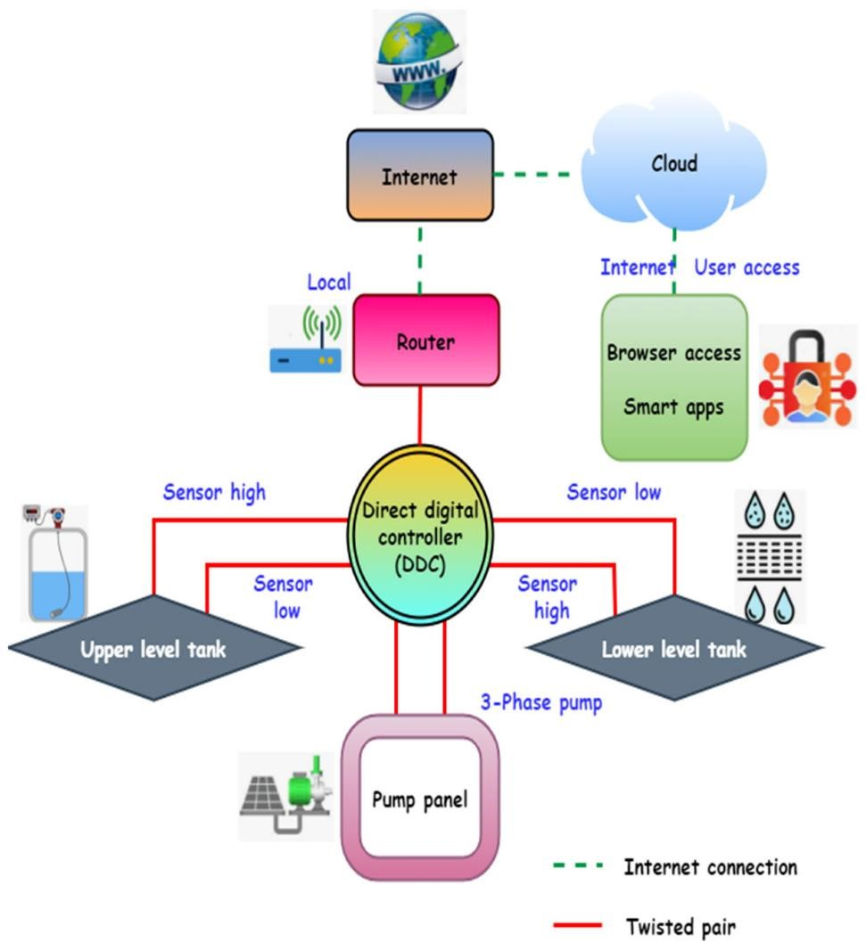

It is used to monitoring the salt content of the sewage water and communicate with microcontroller for posting this information to internet. It has consists of two rods one is reference rod and measuring rod. The voltage is given to the reference rod and the conducting current passes to measuring rod. The voltage present in the measuring rod is proportional to the salt content of the water.

The turbidity sensor SKU: SEN0189 is used to detect water quality by measuring level of turbidity. The turbidity sensor enables the detection of suspended particles in water.

To the microcontroller unit (MCU). The threshold is adjustable by adjusting the potentiometer in digital signal mode. The operating voltage of the turbidity sensor is 5V DC and the operating current is 40mA (max) respectively.

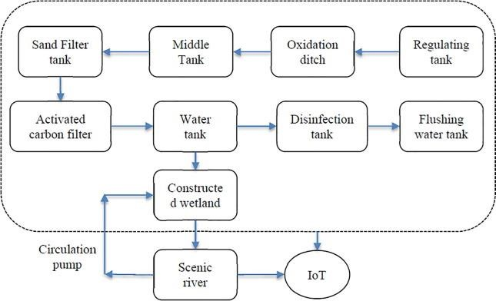

The circuit diagram consist of microcontroller, IoT module, wireless Trance receiver, buzzer. This circuit is used to post the data to the internet by collecting the data from industrial sewage waste monitoring system. The wireless Trance receiver module is connected to the pin number of microcontroller D8 to D13.

IOT module is connected to the microcontroller in pin number of d2 d3. The module split the data from microcontroller to internet through Wi-Fi router. IOT module device consist of TCP/ IP self-supported programming module can include header and trailer frame format. From microcontroller data send to module is pre processed in HTML language.

This transceiver module is send to data to microcontroller through serial format with address. The program used in the microcontroller is filter the address and data and send the corresponding module of the program. This data is separate and display in the LCD display and send to the IOT module. The user has to in the browser which will connect the browser to the IOT module through Router.